Art Doc

We wanted to make Gauntlet into a horror aesthetic, but not to make it a horror game. Something more like a schlocky action movie where it has horror aesthetics without being scary. We wanted to evoke the feeling of “doomguy in the resident evil mansion”.

# Concept Art:

Art that we had initially made to be used for development that weren’t fully implemented



# In-Game Assets:

### Tiles:



### Walls



### Items and Interactables:



### Enemy sprites and spawner:



### Player sprites:



### Menu Screen:

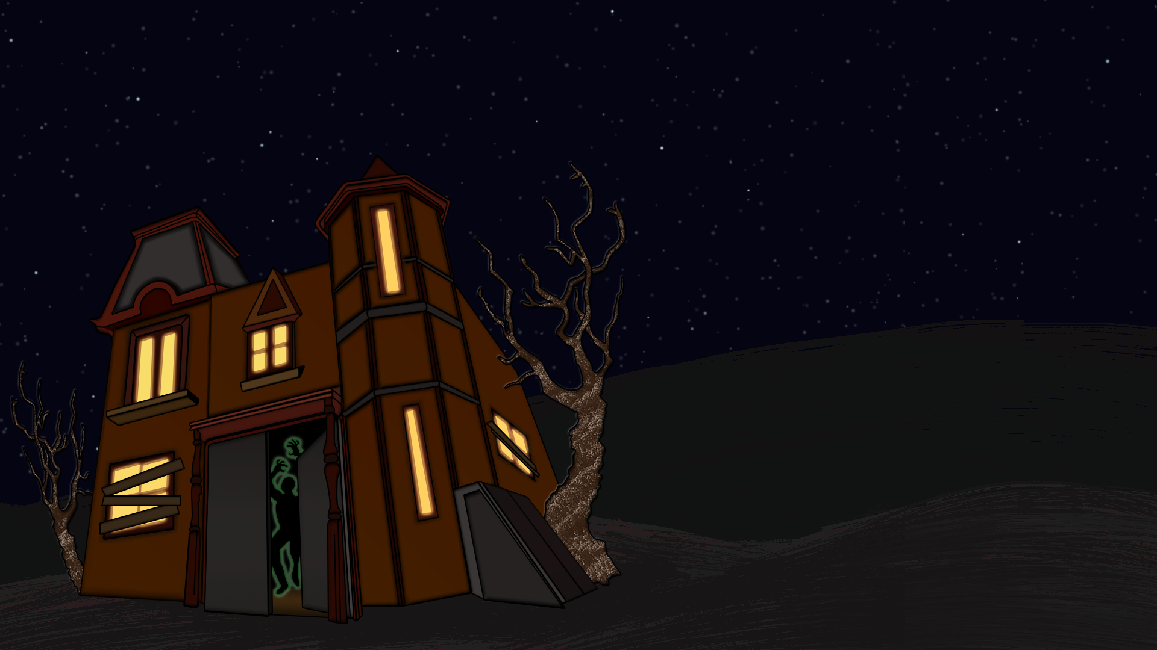

### HUD

